

Air Temperature and Relative Humidity Investigation

SUBJECT: Earth Science

GRADE LEVEL: 6th-8th

DEPTH OF KNOWLEDGE LEVEL: 2

AUTHOR: Dr. Lawrence Rudd, School of Education, Nevada State College, [Lawrence.rudd@nsc.edu](mailto:Lawrence.rudd@nsc.edu)

NEXT GENERATION SCIENCE STANDARDS:

1. [Weather and climate are influenced by interactions involving sunlight, the ocean, the atmosphere, ice, landforms, and living things. These interactions vary with latitude, altitude, and local and regional geography, all of which can affect oceanic and atmospheric flow patterns. (MS-ESS2-6)](http://www.nap.edu/openbook.php?record_id=13165&page=186)
2. [Cause and effect relationships may be used to predict phenomena in natural or designed systems. (MS-ESS2-5)](http://www.nap.edu/openbook.php?record_id=13165&page=87)
3. [Graphs, charts, and images can be used to identify patterns in data. (MS-ESS3-2)](http://www.nap.edu/openbook.php?record_id=13165&page=85)
4. [Cause and effect relationships may be used to predict phenomena in natural or designed systems. (MS-ESS3-4)](http://www.nap.edu/openbook.php?record_id=13165&page=87)

PRIOR KNOWLEDGE: Students should know the basic weather variables, especially the different ways to express humidity. Students should also have made and interpreted graphs of earth science data.

INTRODUCTORY ACTIVITY: Use a psychrometer to find the relative humidity of the air in the classroom. Knowing the relative humidity, students should be able to make some general statements about the air’s water vapor capacity and how the air’s ability to hold moisture would change with cooling or heating.

CONCEPT/SKILL DEVELOPMENT:

**Objective:**

The purpose of this investigation is to understand the relationship between relative humidity and temperature for a Transect Data Site.

**Driving Question:**

What is the relationship between relative humidity and temperature at a transect data site over a period of one week?

**Materials:**

Instructions (below)

Temperature and Relative Humidity graph for the Sheep Range Blackbrush Research Site

Access to the Nevada Climate Change Data Portal

**Important Terms:**

Relative Humidity

Temperature

Sheep Range

Blackbrushplant community zone

**Resources**

<http://www.weather.com/encyclopedia/>

Descriptions of a variety of storms and weather phenomena in an encyclopedic format.

<http://www.exploringweather.com/index.html>

A site that focuses on storms, as well as the process of weather forecasting. This site also includes a useful glossary of weather terms.

<http://sensor.nevada.edu/NCCP/Default.aspx>

The Nevada Climate Change Portal. This site explains the Nevada Climate Change project.

<http://daymet.ornl.gov/custom_home>

This site gives access to a model that provides weather data for North America from 1980 to 2011. Click on Daily Data for a Single Pixel in the left-hand column to get weather data for any location in North America.

**Investigation:**

**Examine the Temperature and Relative Humidity graph for the Sheep Range Blackbrush Research Site (Figure 1) and answer the following questions.**

1. Use the following site to view images of the Sheep Range Blackbrush site: <http://sensor.nevada.edu/NCCP/Climate%20Monitoring/Web%20Cameras.aspx>

Click on the Latest Images link in the Sheep Range Blackbrush bar to view images of this site.

Describe this area. Make sure that you describe the plants that you see as well as the topography (how hilly or flat the area is).

1. Do you think that this place is wet or dry? Describe the observations that led you to your conclusion.

**Use the graph of Relative Humidity and Temperature vs. Date for the Sheep Range Blackbrush Research Site (Figure 1) to answer the following questions. Figures 2 and 3 show the individual temperature and relative humidity data. You may want to start this investigation by first looking over figures 2 and 3.**

1. Which day had the highest temperature and what time of day did that temperature occur?
2. Define relative humidity. When you know the relative humidity of a parcel of air what does it tell you about the air?
3. Which day had the lowest relative humidity value and when did it occur?
4. When the temperature goes up what usually happens to the relative humidity?
5. What do you think causes the relative humidity to change when the temperature changes?
6. How do you think that this graph would change for a wetter, higher-elevation location in the Sheep Range such as the Pinyon-Juniper, Montane, or Subalpine zones? Look up images of these vegetation zones on the site:

<http://sensor.nevada.edu/NCCP/Climate%20Monitoring/Web%20Cameras.aspx>

**Extension**

How to you think that a temperature-relative humidity vs. time graph that covers a week in June would look for where you live? Describe the climate (temperature and precipitation) for where you live and then draw a simple sketch graph to go along with your description.

CLOSING ACTIVITY: Write a statement that summarizes how dew point and relative humidity tend to change throughout the day. Find weather data online that you can use as evidence to back-up your statement.

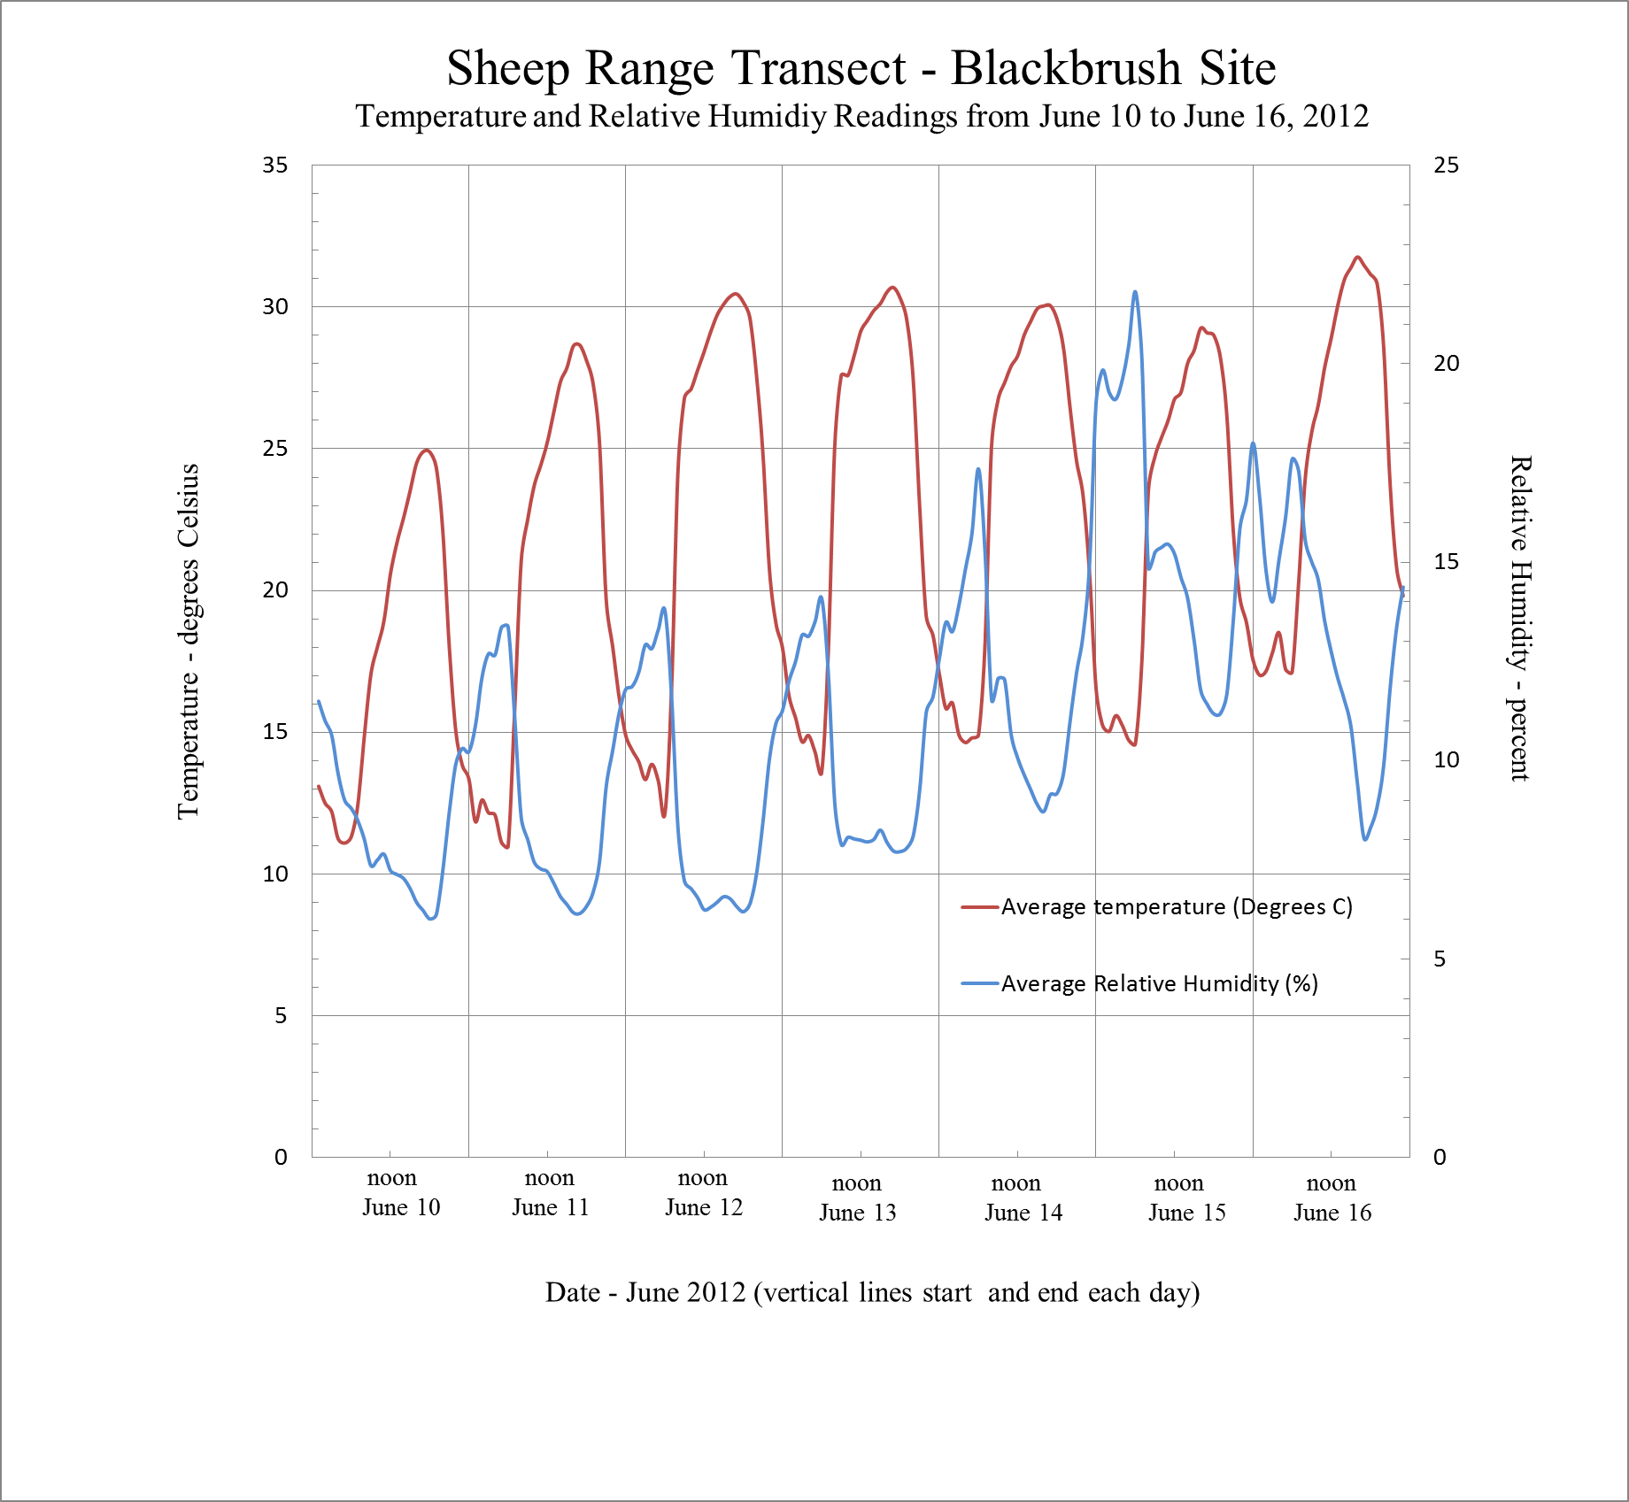

**Figure 1.** Plot of average hourly temperature and relative humidity readings from June 10 to June 16, 2012 at the Blackbrush Station of the Sheep Range Transect, Nevada Climate-ecohydrology Assessment Network.

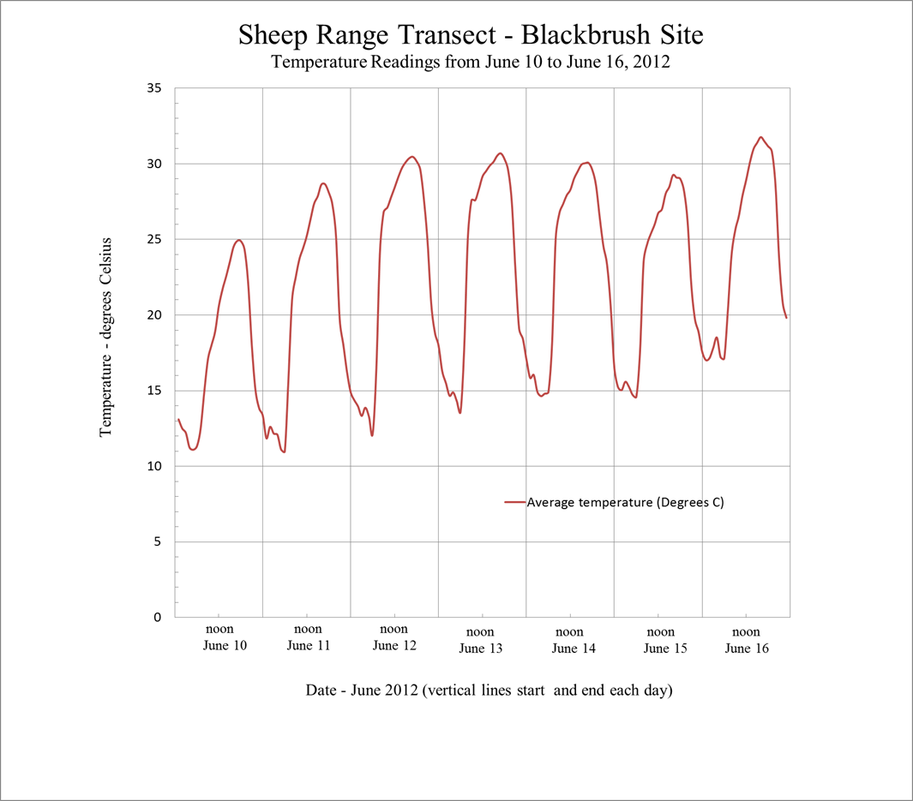

**Figure 2.** Hourly average temperature readings from June 10 to June 16, 2012 at the Blackbrush Station of the Sheep Range Transect, Nevada Climate-ecohydrology Assessment Network.

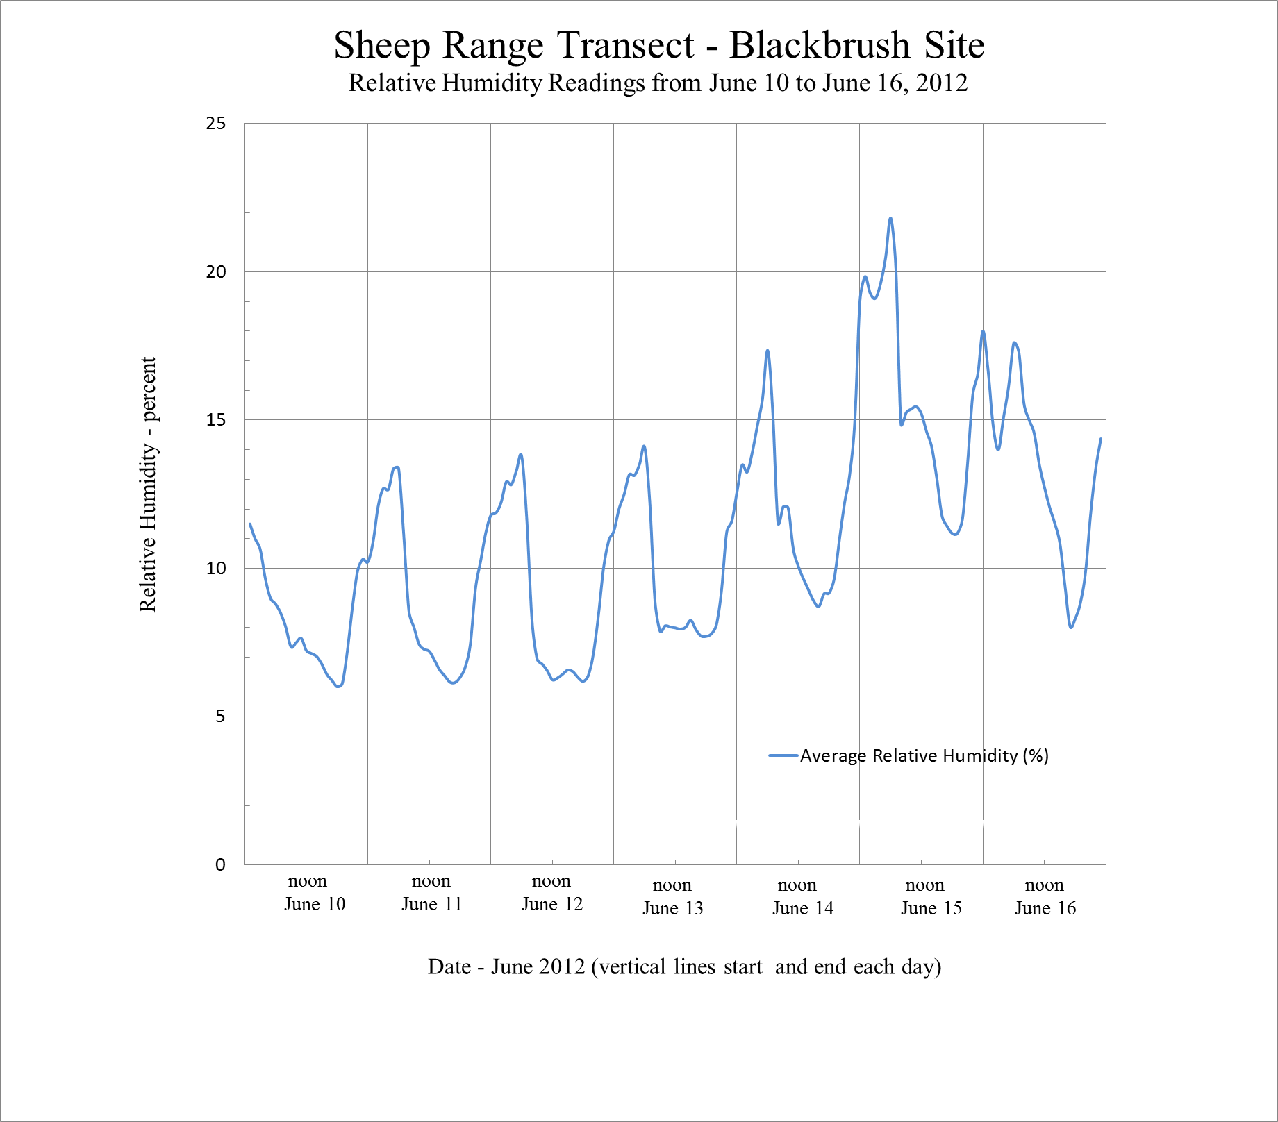

**Figure 3.** Hourly average relative humidity readings from June 10 to June 16, 2012 at the Blackbrush Station of the Sheep Range Transect, Nevada Climate-ecohydrology Assessment Network.